new patient intake form
Name: DOB/AGE:
Street Address:
City, State, Zip:
Phone--Home: Mobile:
Email:
Please indicate how you would like to be contacted: ☐Home phone ☐Mobile ☐Text ☐Email
Emergency contact name and number:
Your occupation:
Marital status:
Living situation:
Whom may I thank for referring you?
Please list the names & phone numbers of any Drs. Or Practitioners you would like me to consult with:

Please list ALL prescription and non-prescription drugs (i.e. over the counter, vitamins, supplements, herbs, etc.) currently being taken. Include any taken occasionally, such as aspirin for headaches, as well as those taken daily. (Use back of page if needed.)
Name | Dose and how often | Reason for Taking
What is the primary concern you would like to address in treatment?

Other issues or concerns?

Musculoskeletal:
Using an X, please indicate any areas of current pain or weakness of the diagram below:
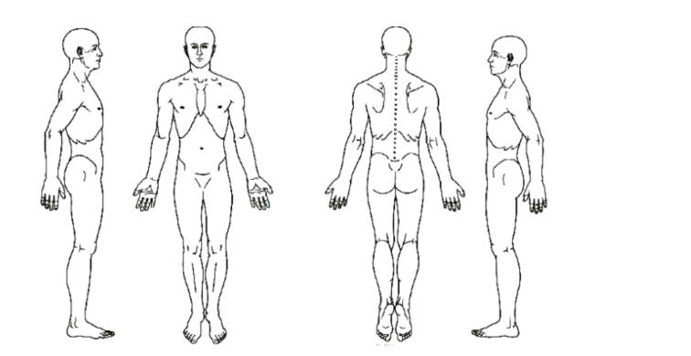
Please describe each:

Please list any past accidents, injuries or surgeries, including dates:

Do you experience numbness and/or tingling in any part of your body? ☐Yes ☐No
If yes, please explain:

Exercise:
Type and frequency of exercise / movement:
Sleep:
What time do you go to sleep?
What time do you wake?
Do you feel rested when you wake? ☐Yes ☐No
Difficulty: ☐Falling asleep ☐Staying asleep ☐Toss & turn ☐Waking early, unable to get back to sleep
Dreams: ☐Vivid dreams ☐Nightmares ☐I don’t dream
Other sleep issues:
Temperature:
Do you tend to feel hot or cold and/or experience hot flashes or cold chills? ☐Yes ☐No
If yes, please explain:
Do your feet and/or hands tend towards cold? ☐Yes ☐No
If yes, please explain:
Stress & Anxiety:
What is your level of stress and/or anxiety on a scale of 1 -10 (10 being the most stressed / anxious):
What triggers your stress / anxiety?
Do you have panic attacks? ☐Yes ☐No
If yes, please describe:
What helps you conquer stress / anxiety?
Energy level:
(Use a scale of 1 -10, 10 being having enough energy to get through your day easily with some left over)
Overall:
Upon waking:
Time of day of peaks and low ebbs:
Headaches:
Do you get headaches? ☐Yes ☐No
If yes, how often? ☐Occasionally ☐Weekly ☐Daily
Where does it occur in or on your head, and what does it feel like? ____________________________
Do you experience dizzy spells? ☐Yes ☐No
If yes, how often? ☐Occasionally ☐Weekly ☐Daily
Memory:
Do you have any issues with your memory? ☐Yes ☐No
If yes, please explain:
“Foggy” brain or “fuzzy” thinking? ☐Yes ☐No
If yes, please explain:
Eyes: Issues with ☐Vision ☐Floaters ☐Dryness ☐Redness ☐Itchy Other:
Nose: ☐Congestion ☐Runny ☐Decreased sense of smell Other:
Ears: ☐Ringing ☐Loss of Hearing ☐Sound Sensitivity ☐Rushing Noise Other:
Allergies:
Do you have allergies to foods, products, and/or environment: ☐Yes ☐No
If yes, please explain:
Is it seasonal: ☐Yes ☐No
Teeth/Jaw: ☐TMJ ☐Teeth Grinding ☐Jaw Pain Other:
Chest & Breathing:
☐Tightness ☐Pain ☐Palpitations ☐Asthma ☐Shortness of Breath Other:
How often? ☐Occasionally ☐Weekly ☐Daily Other:
Cough: ☐Morning ☐Daytime ☐Nighttime ☐All the time
Is it: ☐Dry ☐Phlegm Producing ☐Difficult to expectorate Phlegm
What color, if any, is the phlegm? ☐Clear ☐White ☐Yellow ☐Brown ☐Green
Do you use tobacco (currently or in the past)? ☐Yes ☐No
If yes, for how long and how often per day / week?
Appetite:
Do you get hungry during the day? ☐Yes ☐No
Do you feel like you eat too much or too little? ☐Too much ☐Too little ☐No
Do you feel energized after eating or feel like you need a nap? ☐Energized ☐Nap
Do you crave anything:
Diet: What does your food intake on a typical day look like? Please include times of meals.
Breakfast:
Lunch:
Dinner:
Snacks:

Digestion:
Do you experience: ☐Bloating ☐Pain after eating ☐BM after eating ☐Frequent gas ☐Heartburn ☐Reflux
Other:
Abdominal Pain:
Location of pain (if any): ☐Middle Abdomen ☐Lower Abdomen ☐Both
Related to food intake? ☐Yes ☐No ☐Sometimes
What does the pain feel like? ☐Dull ☐Sharp ☐Like a Spasm
What makes it feel better? ☐Pressure ☐Heat ☐Cold Other:
Fluid Intake:
Do you get thirsty? ☐Yes ☐No
How much water do you drink in a day?
How much coffee do you drink in a day?
What kinds of soda do you drink and how often?
What other kinds of beverages (including alcohol) do you drink and how often?

Do you consume “diet” drinks with sugar substitutes? ☐Yes ☐No
If yes, what kind?
What temperature do you prefer your drinks to be? ☐Cold ☐Room Temp ☐Warm ☐Hot
Bowels:
How many times a day/week do you have a BM?
Any difficulty in going? ☐Yes ☐No If yes, please describe:
Any pain? ☐Yes ☐No If yes: ☐Before ☐During ☐After
Any blood or mucus in your stool? ☐Yes ☐No
Stool description(s): ☐Well formed ☐Soft ☐Tend toward diarrhea ☐Tend toward constipation
Is the stool ever extra smelly? ☐Yes ☐No Any current or past hemorrhoids? ☐Yes ☐No
Urination:
Do you feel your output is about equal to your intake? ☐Yes ☐No
Any dribbling? ☐Yes ☐No Any incontinence? ☐Yes ☐No
Any blood in your urine? ☐Yes ☐No Does it ever burn? ☐Yes ☐No
Color of urine? ☐Clear ☐Light yellow ☐Yellow ☐Dark Yellow
Menstruation:
Age of onset: Age of menopause:
Number of days in cycle:
Duration of period:
Color of menses:
Any clots? ☐Yes ☐No If yes, what size? ☐Pea ☐Dime ☐Quarter Other:
Pain (before or during period): ☐Yes ☐No ☐Sometimes Pain level 1 – 10 (10 being worst):
What makes it feel better? ☐Pressure ☐Heat ☐Cold Other:
Breast tenderness: ☐Yes ☐No ☐Sometimes
Mood changes: ☐Yes ☐No ☐Sometimes
Hot flashes: ☐Yes ☐No ☐Sometimes
Any other PMS symptoms:
Pregnancy History:
Are you currently pregnant? ☐Yes ☐No If yes, how many weeks? Due Date:
Number of previous pregnancies: Number of births:
Health during pregnancy:
Complications during labor and delivery:
Health postpartum:
Are you currently breastfeeding? ☐Yes ☐No
Prostate:
Have you had a prostate exam? ☐Yes ☐No
If yes, when?
Any concerns? ☐Yes ☐No
If yes, please explain:
Please Briefly describe your vision of yourself in perfect health:

I hereby certify that the information above is complete and to the best of my knowledge.
Patient Printed Name: Date:
Patient Signature (Signature of parent or guardian if under 18):

